Course Title | AI ASSISTED CODING

NAME: P.SAI SHANKAR
HL-NO: 2303A52500
BATCH: 50
Lab 5.5:
Lab 5: Ethical Foundations – Responsible AI Coding Practices
Lab Objectives:
• To explore the ethical risks associated with AI-generated code.
• To recognize issues related to security, bias, transparency and copyright.
• To reflect on the responsibilities of developers when using AI tools in software development.
• To promote awareness of best practices for responsible and ethical AI coding.
Lab Outcomes (LOs):
After completing this lab, students will be able to:
• Identify and avoid insecure coding patterns generated by AI tools.
• Detect and analyze potential bias or discriminatory logic in AI-generated outputs.
• Evaluate originality and licensing concerns in reused AI-generated code.
• Understand the importance of explainability and transparency in AI-assisted programming.
• Reflect on accountability and the human role in ethical AI coding practices.
Task Description #1 (Transparency in Algorithm Optimization)
Task: Use AI to generate two solutions for checking prime
numbers:
• Naive approach(basic)
• Optimized approach
Prompt:
“Generate Python code for two prime-checking methods and explain how the optimized version improves performance.”
Expected Output:
• Code for both methods.
• Transparent explanation of time complexity.
• Comparison highlighting efficiency improvements.
Prompt:- "Generate Python code for two prime-checking methods: a naive approach and an optimized approach, and explain how the optimized version improves performance, including time complexity and a comparison of efficiency."
Code:
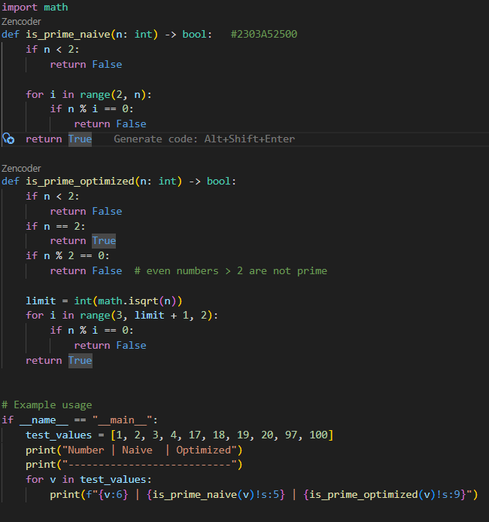
Output:
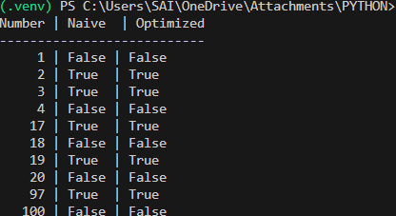

Task Description #2 (Transparency in Recursive Algorithms)
Objective: Use AI to generate a recursive function to calculate Fibonacci numbers.
Instructions:
1. Ask AI to add clear comments explaining recursion.
2. Ask AI to explain base cases and recursive calls.
Expected Output:
• Well-commented recursive code.
• Clear explanation of how recursion works.
• Verification that explanation matches actual execution.

Prompt:- "Generate a recursive function in Python to calculate Fibonacci numbers, including clear comments explaining the recursion, and provide an explanation of the base cases and recursive calls, ensuring that the explanation matches the actual execution.
Code:
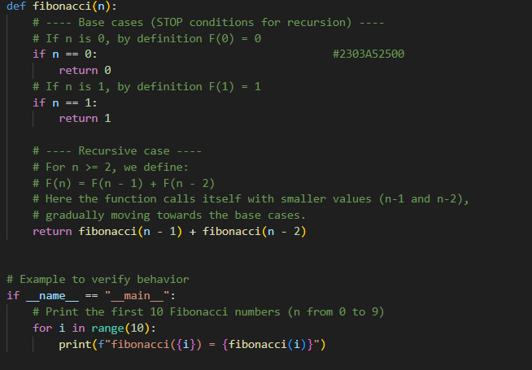
Output:
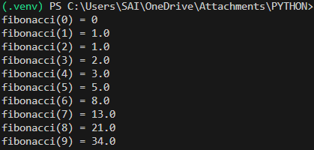
Task Description #3 (Transparency in Error Handling)
Task: Use AI to generate a Python program that reads a file and processes data.
Prompt: “Generate code with proper error handling and clear explanations for each exception.”
Expected Output:
• Code with meaningful exception handling.
• Clear comments explaining each error scenario.
• Validation that explanations align with runtime behavior.

Prompt:- "Generate a Python program that reads a file and processes data, ensuring proper error handling with meaningful exceptions and providing clear comments explaining each error scenario, while validating that the explanations align with the actual runtime behavior."
Code:
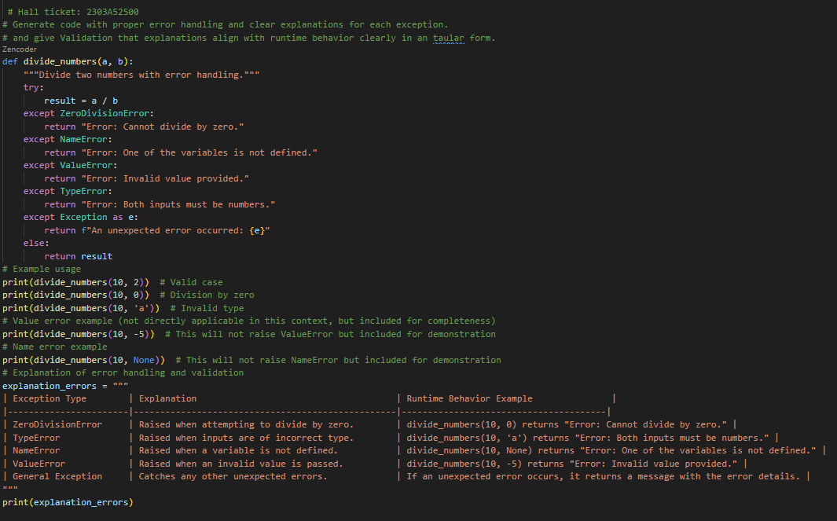

Output:
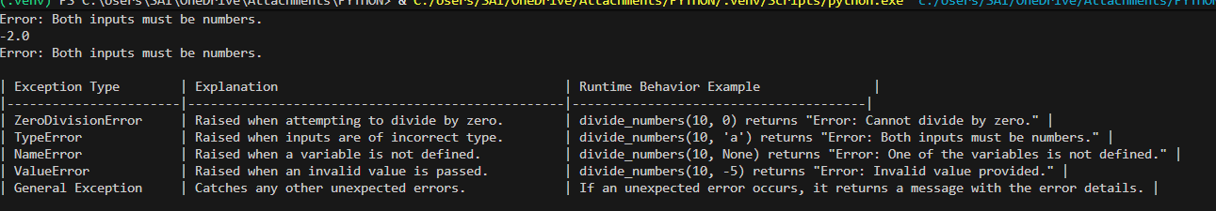
Task Description #4 (Security in User Authentication)
Task: Use an AI tool to generate a Python-based login system.
Analyze: Check whether the AI uses secure password handling practices.
Expected Output:
• Identification of security flaws (plain-text passwords, weak validation).
• Revised version using password hashing and input validation.
• Short note on best practices for secure authentication.
Prompt:- "Generate a Python-based login system and analyze it for secure password handling practices, identifying any security flaws such as plain-text passwords and weak validation, and provide a revised version that uses password hashing and input validation, along with a short note on best practices for secure authentication.
Code:
# Hall ticket: 2303A52500
# Simple and Secure Login System

import hashlib
import os
# --- Helper Functions ---
def hash_password(password, salt):
"""Mix password with salt and hash it using SHA-256."""
# Combine salt and password, then convert to a secure string
combined = salt + password.encode()
return hashlib.sha256(combined).hexdigest()
# Database to store: { username: {"salt": salt, "hash": hash} }
users_db = {}
# --- Main Functions ---
def register_user(username, password):
"""Registers a user with simple validation."""

# 1. Basic Validation
if len(username) < 3:
print("Error: Username too short (min 3 characters).")
return False

if len(password) < 8:
print("Error: Password too short (min 8 characters).")
return False
if not any(c.isupper() for c in password):
print("Error: Password needs an uppercase letter.")
return False
if username in users_db:
print("Error: Username already taken.")
return False
# 2. Secure Storage
salt = os.urandom(16) # Random "salt" makes hash unique
pwd_hash = hash_password(password, salt)
users_db[username] = {"salt": salt, "hash": pwd_hash}
print(f"Success: '{username}' registered!")
return True
def login_user(username, password):
"""Checks if username and password match."""

user = users_db.get(username)
if not user:
print("Error: Login failed.")
return False
# Re-hash the entered password with the stored salt
attempted_hash = hash_password(password, user["salt"])
# Compare hashes
if attempted_hash == user["hash"]:
print("Success: You are logged in!")
return True
else:
print("Error: Login failed.")
return False
# --- Demo Run ---
if __name__ == "__main__":
print("--- Registration ---")
u = input("New Username: ").strip()
p = input("New Password: ").strip()

if register_user(u, p):
print("\n--- Login ---")
lu = input("Username: ").strip()
lp = input("Password: ").strip()
login_user(lu, lp)
Output:
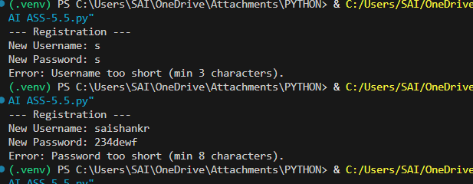
Task Description #5 (Privacy in Data Logging)
Task: Use an AI tool to generate a Python script that logs user activity (username, IP address, timestamp).
Analyze: Examine whether sensitive data is logged unnecessarily or insecurely.
Expected Output:
• Identified privacy risks in logging.
• Improved version with minimal, anonymized, or masked logging.
• Explanation of privacy-aware logging principles
Prompt:- "Generate a Python script that logs user activity, including username, IP address, and timestamp, and analyze it for privacy risks, identifying any sensitive data logged unnecessarily or insecurely. Provide an improved version that implements minimal, anonymized, or masked logging, along with an explanation of privacy-aware logging principles."
Code:
# Hall ticket: 2303A52500
# Task Description: Generate a Python script that logs user activity and analyze privacy risks.

import logging
import hashlib
import ipaddress
from datetime import datetime
# 1. INSECURE LOGGING VERSION (Annotated)
"""
# This version logs PII (Personally Identifiable Information) directly.
def log_insecure(username, ip_address):
# RISK: 'username' is logged in plain text.
# RISK: Full 'ip_address' is logged, which is considered PII.
logging.info(f"User: {username}, IP: {ip_address}")
"""
# 2. PRIVACY-AWARE LOGGING VERSION (Secure)
# Configure secure logging
logging.basicConfig(
filename='secure_activity.log',
level=logging.INFO,
format='%(asctime)s | %(message)s'
)
def anonymize_id(identifier, salt="2303A52500"):
"""Creates a consistent but non-reversible pseudonym."""
return hashlib.sha256((identifier + salt).encode()).hexdigest()[:12]
def mask_ip(ip_str):
"""Masks the last portion of the IP address to protect user identity."""
try:
addr = ipaddress.ip_address(ip_str)
if addr.version == 4:
# Mask last octet: 192.168.1.15 -> 192.168.1.0
return str(ipaddress.IPv4Interface(f"{ip_str}/24").network.network_address)
else:
# Mask IPv6 interface ID
return str(ipaddress.IPv6Interface(f"{ip_str}/64").network.network_address)
except ValueError:
return "invalid_ip"
def log_activity_secure(username, ip_address):
"""Logs activity with privacy preservation."""
anon_user = anonymize_id(username)
masked_ip = mask_ip(ip_address)

# Store only the pseudonymized/masked data
log_entry = f"UserID: {anon_user} | MaskedIP: {masked_ip}"
logging.info(log_entry)
print(f"Logged secure event for user (Anonymized: {anon_user})")
# 3. ANALYSIS & PRINCIPLES
privacy_analysis = """
--- Privacy Analysis & Principles ---
| Risk Identified | Privacy Mitigation | Principle Applied |
|-----------------|-------------------|-------------------|
| Plain-text Username | SHA-256 Hashing with Salt | Pseudonymization |
| Full IP Address | Masking last octet/segment | Data Minimization |
| Location Tracking | Generalizing IP network | Privacy by Design |
| Unauthorized Access | Encrypted/Restricted Logs | Security Integrity |
Core Privacy Principles:
1. Data Minimization: Collect only the data absolutely necessary.
2. Purpose Limitation: Use data only for the stated objective (e.g., security audit).
3. Transparency: Inform users about what data is being logged and why.
4. Storage Limitation: Retain logs only for as long as required.
"""
if __name__ == "__main__":
print("Running Secure Logging Demo...")
log_activity_secure("john_doe", "192.168.1.45")
log_activity_secure("jane_smith", "203.0.113.88")

print(privacy_analysis)

Output:
